Borrador inicial:
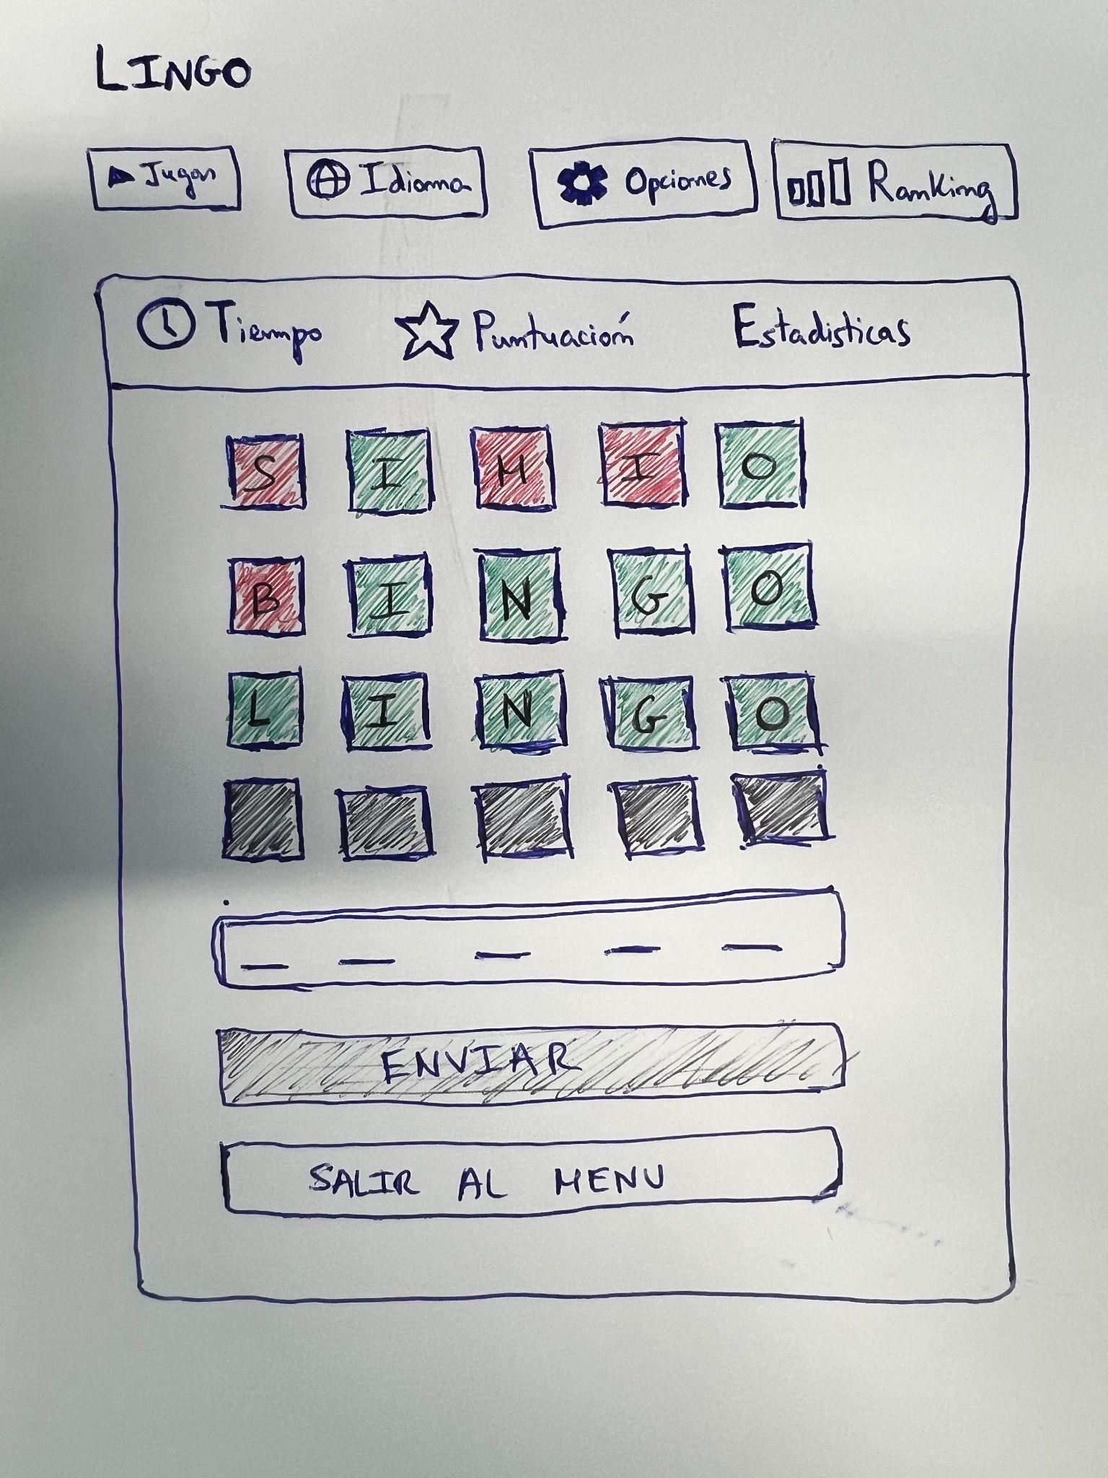

Borrador FIGMA:
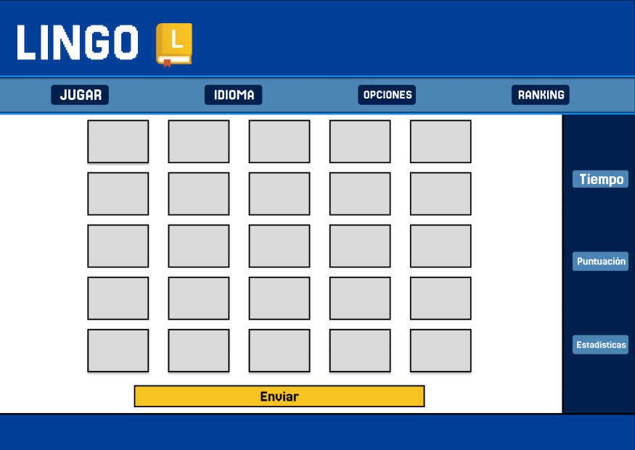

FIGMA:https://www.figma.com/design/PuzKDEic3iME3AiSW2BHDz/LINGO?node-id=0-1&p=f&t=4zYSOfgJ4MuzT4fU-0

